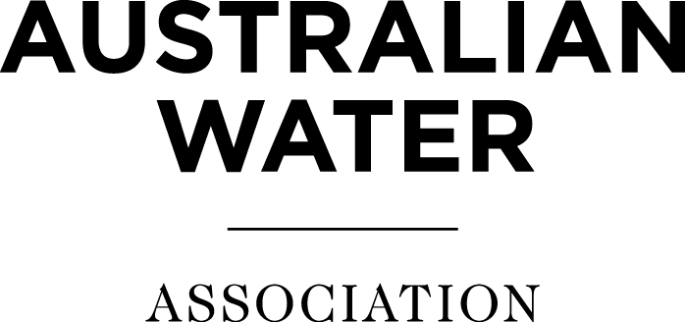

2021 Joint Symposium on Inland Water in Western Australia
Abstract Submission Template
Abstracts will be peer reviewed to determine presentations for the event program. It should be noted that all presentations will be made publicly available to attendees following the event.
*Primary Presenter Name
*Organisation
*Email address
*Phone Number
*Presentation Title
10 words or less
Topic/Area
*Co-Presenters and Organisation
All co-presenters and their organisation must be listed
Author/s and Organisation
If different to Presenter/s
*Abstract
200 words or less
*About the Presenter/s
The information written here will be used to introduce the presenters.

Please fill in for all presenters in 100 words or less per presenter, links to online profiles will not be accepted.
Template Source: Goldfields Environmental Management Group

